Borel distribution

Def

Parameter



Support



PDF



Expected Value



Variance



Property

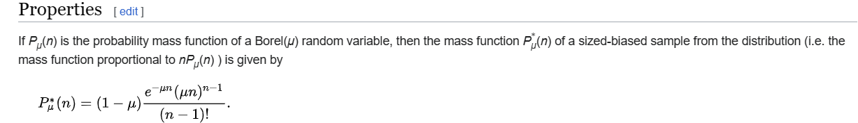

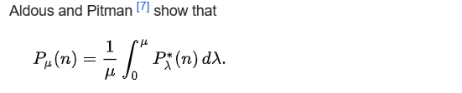

Ref

[Borel distribution - Wikipedia](https://en.wikipedia.org/wiki/Borel_distribution)